1 (a) First solve IRR using excel IRR function as below; The yield to maturity is twice the IRR per half year, which is 6.82%

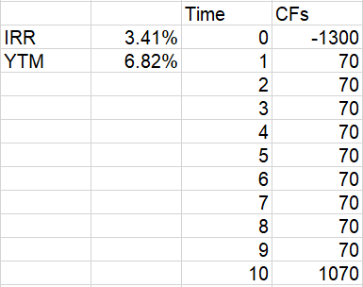

1 (b)

Calculation:

Months since insurance = range(0,60)

# Unpaid Coupon = 10 – INT(Months since insurance / 6)

PV of coupon (“clean”) = PV(IRR = 3.41%, # Unpaid Coupon, -70, 0, 0)

PV of principal = 1000/((1+IRR)^(60 - Months since insurance / 6))

CLEAN PRICE = PV of coupon (“clean”) + PV of principal

1 – w = MOD(6- Months since insurance, 6) / 6

Accrued interest = (1-w) * 70

DIRTY PRICE = CLEAN PRICE + Accrued interest

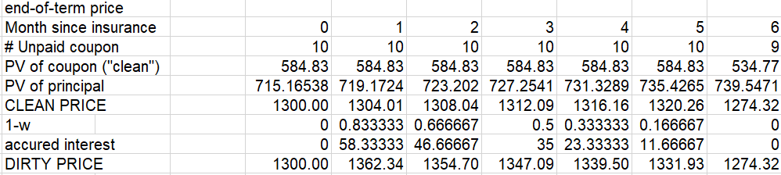

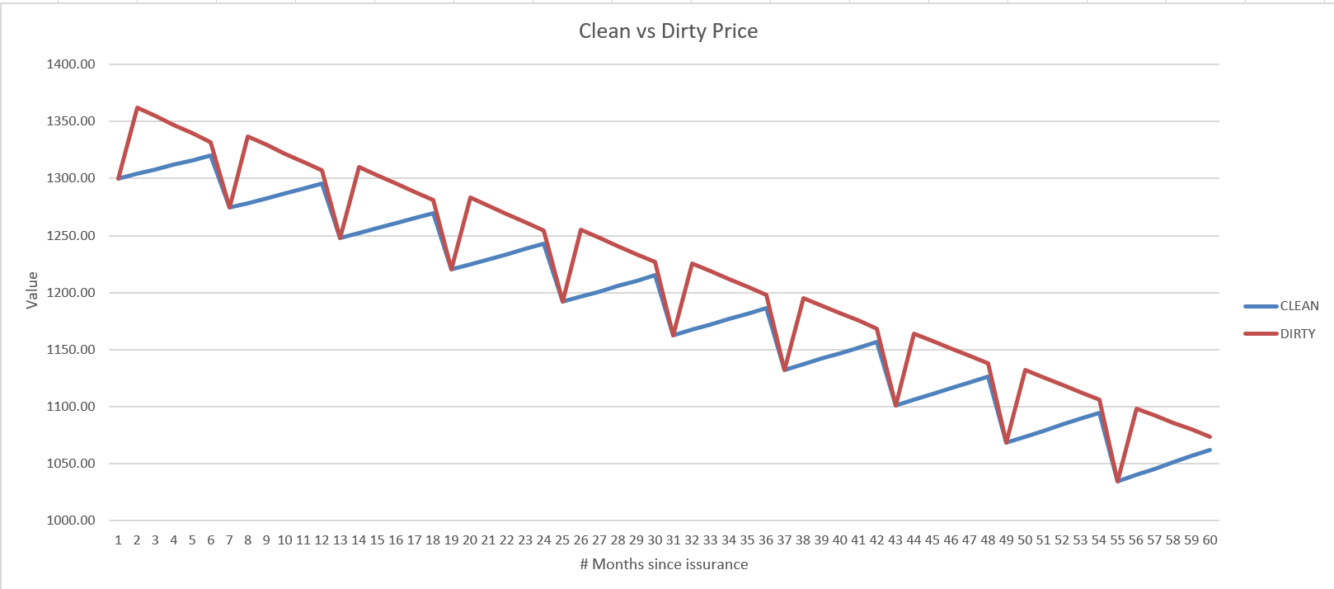

1(c)

Clean price is smoother since it ignores monthly change in the PV of future coupon payments.